RECAO EPA Supporting Document

Guidance - Employers, Training Providers & Apprentices

Level 3 Recruiter Standard ST1421

Document Reference Table
Document Reference: |  |  | EPAOPol_GuiDoc_SC_0125
Apprenticeship Standard: |  |  | Recruiter ST1421 v1.0 January 2025
Document Title: |  |  | Guidance Document - Employers, Training Providers & Apprentice
Date of Issue: |  |  | 15/01/2025
Version: |  |  | 1
Date of Next Review: |  |  | January 2026
Document Owner: |  |  | RECAO Responsible Officer
Contact: |  |  | centres@rec.uk.com
Address |  |  | RECAO, 20 Queen Elizabeth Street, SE1 2LS
Associated Conditions:
Policy is for the use of: |  |  | Current and prospective REC EPA Centres, Centre Staff, Apprentices, Employers and AO Staff.
Associated Policies:
Date | Owner | Section | Amendment
07/2025 | SC | All | New Document

Contents
1. Contents 4
2. Introduction 7
2.1. Overview 7
2.2. Level 3 Recruiter –The Process 9
2.2.1. MOU (Memorandum of Understanding) 9
2.2.2. Registration 9
2.2.3. Gateway 9
2.2.4. Reasonable adjustments or special considerations 9
2.2.5. EPA planning meeting 10
2.3. Invoicing 10
3. EPA Assessment 12
3.1. Assessment method 1 - Presentation and Questioning 12
3.1.1. Presentation overview 12
3.1.2. Presentation themes: 12
3.1.3. Example presentation topics: 12
3.1.4. On the day of the live assessment 13
3.1.5. Questioning overview 13
3.1.6. Grading 14
3.2. Assessment method 2- Professional Discussion 15
3.2.1. Overview 15
3.2.2. Portfolio of evidence requirements: 16
3.2.3. Grading 18
3.3. Overall EPA grading 18
3.4. Re-sits and re-takes 18
4. Appendices 20
4.1. Appendix 1: Portfolio evidence locator document for Level 3 Recruiter Apprenticeship ST1421 – v1.0 End Point Assessment 20
4.2. Appendix 2: Presentation Declaration of Authenticity Form 27
4.3. Appendix 3: Portfolio Declaration of Authenticity Form 28
4.4. Appendix 4: Gateway Readiness Declaration Form 29
4.5. Appendix 5: Recruiter Level 3 Standard ST1421 Assessment Plan 30
4.6. Appendix 6: Recruiter Level 3 Standard ST1421 Assessment Plan 32
5. Policy documents 36
5.1. Appendix 7 Proof of Identity Policy 37
5.2. Appendix 8 Use of Artificial Intelligence 38
5.3. Appendix 9 Reasonable Adjustments 39
5.4. Appendix 10. Special Consideration 41

Introduction
This document explains the requirements for end-point assessment (EPA) for the Level 3 Recruiter Apprenticeship (ST1421).
A full-time recruiter apprentice typically spends 18 months on-programme. The apprentice must spend at least 12 months on-programme and complete the required amount of off-the-job training in line with the apprenticeship funding rules.
The EPA should be completed within an EPA period lasting typically 3 months.
The apprentice must complete their training and meet the gateway requirements before starting their EPA. The EPA will assess occupational competence.
An approved EPAO must conduct the EPA for this apprenticeship. Employers must work with the training provider to select an approved EPAO from the apprenticeship providers and assessment register (APAR).

Overview
There are 2 assessment methods for the Level 3 Recruiter Apprenticeship:
- Assessment method 1 - Presentation with questions: Fail, pass, distinction.
- Assessment method 2 - Professional discussion underpinned by a portfolio of evidence: Fail, pass, distinction.
The result from each assessment method is combined to decide the overall apprenticeship grade. The following grades are available for the apprenticeship: Fail, pass, distinction.
The assessment methods can be delivered in any order, but it is recommended that the presentation is done first, followed by the Q&A and then the professional discussion. The result of one assessment method does not need to be known before starting the next.
On-programme – typically 18 months | The apprentice must:  - Complete training to develop the knowledge, skills and behaviours (KSBs) outlined in this apprenticeship’s standard (see appendix 5 and 6).  - Complete training towards English and Mathematics level 2 qualifications in line with the apprenticeship funding rules.  - Complete 20% off the job training requirements, (i.e. if the apprentice works 30 hours a week, a minimum of 6 hours a week should be on off the job training).  - Compile a portfolio of evidence (Typically 15 pieces of evidence).
End-point assessment gateway requirements. | The apprentice’s employer must be content that the apprentice is occupationally competent.  The apprentice must:  - Confirm they are ready to take the EPA.  - Have achieved English and Mathematics qualifications at level 2 in line with the apprenticeship funding rules.  For the professional discussion underpinned by a portfolio of evidence, the apprentice must submit a portfolio of evidence. It is suggested that the portfolio comprises a collection of around 15 pieces of evidence. Evidence must be mapped against the KSBs (appendix 1-mapping document). Evidence may be used to demonstrate more than one KSB. A qualitative as opposed to quantitative approach is suggested.  Evidence sources may include:  - Workplace documentation and records.  - Workplace policies and procedures.  - Witness statements.  - Annotated photographs.  - Video clips with a maximum total duration 10 minutes, the apprentice must be in view and identifiable.  This is not a definitive list as other evidence sources can be included. The portfolio of evidence should not include reflective accounts or any methods of self-assessment.  Any employer contributions should focus on direct observation of performance, for example, witness statements, rather than opinions.  The evidence provided should be valid and attributable to the apprentice and the portfolio of evidence should contain a statement from employer and apprentice confirming this (appendix 3).  Gateway evidence must be submitted to the EPAO, along with any organisation specific policies and procedures requested by the  EPAO.
End-point assessment elements  Period -typically 3 months | Assessment methods  - Presentation with questions:  The apprentice will produce and deliver a presentation to an independent end point assessor (IEPA).  The apprentice must submit their presentation slides and any supporting materials to the RECEPAO by the end of week 7 of the EPA period with the project declaration form (appendix 2).  The presentation and questions will last at least 50 minutes (20 minutes to present and 30 minutes of questions). The IEPA will ask at least 5 questions.  - Professional discussion underpinned by a portfolio of evidence:  The apprentice will have a professional discussion with an IEPA. It will last 60 minutes. They will ask at least 6 questions. The questions will be about certain aspects of the apprentice’s occupation.  The apprentice will need to compile a portfolio of evidence before the EPA gateway which can be used to help the apprentice answer the questions.
Apprenticeship Grading | - Presentation with questions: Fail, pass, distinction.  - Professional Discussion underpinned by a portfolio of evidence: Fail, pass, distinction.  - Overall EPA grade: Fail, pass, distinction.
Professional recognition | This apprenticeship aligns with:  - The Recruitment and Employment Confederation for an Affiliate membership.  - The British Institute of Recruiters for Certified Agency Recruiter (Cert PRec) and Specialist in Talent Acquisition and Retention for In-House Recruiters (STAR).

Level 3 Recruiter –The Process

MOU (Memorandum of Understanding)
The RECAO will agree initial terms of working prior to contract and issue a standard contract regarding EPA services.
Access to all RECAO policies and guidance documents can be found at https://www.rec.uk.com/about-the-rec/awarding-organisation/information-centres

Registration
A minimum of 6 weeks before gateway, apprentices will be registered. This occurs as early as possible to ensure allocations for EPA for each apprentice and to ensure the RECAO can carry out the assessment process as quickly and effectively as possible upon readiness.
The Apprenticeship Provider is responsible for the management of all quality assurance (QA), compliance and potential malpractice issues associated with all apprentices it registers.

Gateway
The apprentice must meet the gateway requirements above before starting their end-point assessment process (EPA). The employer and provider must confirm that the on-programme requirements have been met by the apprentice and the apprentice is ready to undertake the EPA by completing the Gateway Declaration Form (appendix 4). This form should be sent to the RECAO with the apprentice’s Maths and English certificates to epa@rec.uk.com to start the end point assessment process. The customer is responsible for ensuring the accuracy of the information being supplied at gateway.

Reasonable adjustments or special considerations
These will be determined by the RECAO Centre Manager at gateway and the IEPA will be notified before the EPA planning meeting call so they can be discussed in this meeting with the apprentice, employer and/or training provider. If there are any additional learning needs (ALN) requirements or special considerations (SC), the RECAO IEPA will be notified of this and will make the necessary arrangements for the end point assessment.

EPA planning meeting
The RECAO IEPA arranges the post gateway meeting with the apprentice, their manager and/or the Training Provider no later than one week after the gateway has been approved by sending the below email to the apprentice, their manager and/or the Training Provider to arrange this meeting:
Hi ,
I am [insert IEPA full name], this is an introductory email to advise you that I have had the following apprentice assigned to me for End-point Assessment.
- [Insert apprentice full name] - Recruiter apprenticeship standard at level 3
The planning meeting is provisionally booked for [Insert day, date, month, year]. This will take the form of a 30-minute Microsoft Teams conference call and needs to be with the apprentice, manager and/or their mentor for 30 minutes and once agreed I will send you a link to the online meeting.
Please can you confirm this with your apprentice and respond to me via email that this is agreed. (The planning meeting booking date and time can only be changed if agreed by myself so please inform me as soon as possible if there is a mitigating circumstance why this date and time cannot be agreed).
On the call we can discuss any reasonable adjustments that you may or may not have disclosed at gateway that need to be put into place in order for all components of assessment to be completed for the apprentice.
In advance of this call, please can [insert the apprentice first name] email me the market sectors they recruit in to, whether these are permanent, contract or temporary roles and the typical job roles they resource for. This will speed up the process of allocating the presentation title to the apprentice in this meeting.
Kind regards,
[Insert IEPA first name]
[Insert IEPA full name]
Independent End Point Assessor (IEPA)
REC Awarding Organisation
EPA Mobile:
Email:

Invoicing
A charge is made for each apprentice registered at gateway with the RECAO. The RECAO will invoice for all apprentices who completed the Gateway Review in that month.

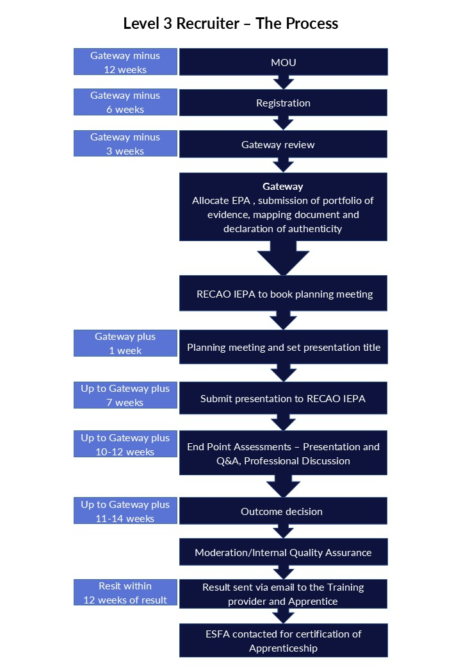

EPA Assessment

Assessment method 1 - Presentation and Questioning

Presentation overview
The apprentice is required to create and deliver a 20-minute presentation based on a title issued by their RECAO IEPA Advisor. A short break of 10 minutes is permitted before a 30-minute Q&A session.

Presentation themes:
The presentation must cover the following 4 themes:

- Organisational strategy – K21, K22, K23, S19, S21

- Technology and software – K19, S15

- Stakeholder engagement and management- K1, K14, S3, S12, S13, B4

- Recruitment processes – K4, L10, L12, K13, K18, S2, S5, S6, S10, B3

The presentation topic title is set by the RECAO IEPA in the post Gateway meeting who will choose one appropriate title from the RECAO bank of topics following the discussion with the apprentice, employer and/or the Training Provider in this meeting.

Example presentation topics:
- Effectively managing stakeholder relationships during a challenging recruitment campaign.
- Utilising technology and software tools to support a recruitment campaign and meet stakeholder requirements.
- Effectively implementing strategies for increasing talent and client pipelines.
- Implementing strategies that have resulted in more sustainable and greener methods of working within recruitment activities and their area of responsibility.
- Methods and techniques for utilising networking and marketing tools to attract more candidates when sourcing vacancies.

The Apprentice has up to 6 weeks to complete their presentation once it has been assigned to the apprentice in the planning meeting by the RECAO IEPA and given any supporting materials. This must be submitted no later than by the end of week 7 from Gateway, to the RECAO IEPA. The IEPA will set the deadline date in the gateway meeting and confirm this date along with the presentation topic title in an email the same day as the gateway meeting to allow the apprentice to have the full 6 week period to produce the presentation.

The below email will be used:
Hi ,
Thank you for your time on the EPA planning meeting call. I have attached the relevant details for your L3 Recruiter End Point Assessment (EPA) presentation.
The presentation (including the signed Declaration of Authenticity attached) must be submitted by 5pm on [insert day, date, month, year] to [insert IEPA mail address] and epa@rec.uk.com
The presentation topic title agreed in the planning call meeting is:
[Insert presentation title and reference number].

Please confirm receipt of this mail.
Kind regards,
Alison
[Insert IEPA first name]
[Insert IEPA full name]
Independent End Point Assessor (IEPA)
REC Awarding Organisation
EPA Mobile:
Email:

The apprentice will submit the presentation and declaration of authenticity form (appendix 2) to the RECAO IEPA for review (it is not assessed) prior to the live assessment day. This will enable the IEPA to select a mandatory question from each of the four KSB areas and possible probing questions in advance of the live assessment to give the apprentice every opportunity of achieving the highest grade possible.

On the day of the live assessment
The Apprentice is required to deliver their 20-minute presentation which is then followed by a 10-minute break before moving onto the 30 minutes of Q&A. There is a 10-minute break between the presentation and Q&A to enable the IEPA to review what has been delivered and adjust questions if required.
TIMINGS:
Presentation: The apprentice has up to 20 minutes (-/+10%) for the presentation. If under the 10% time, the apprentice will be asked if they would like to add anything additional before finishing.
Questioning: The apprentice has 30 minutes and is allowed up to an additional 10% time to finish an answer.

Questioning overview
The IEPA, will ask the apprentice at least 5 questions (one from each of the 4 themes and one closing question from the RECAO question bank) in the live assessment which can be asked in any order.
The IEPA can add their own probe questions after each of the RECAO mandatory questions has been asked to enable the apprentice to cover all the learning outcomes and stretch the apprentice to a distinction level and ensure a natural flow.
The apprentice will be able to refer to the presentation or presentation aides during the Q&A. The presentation will be conducted using video conferencing software and recorded to satisfy the RECAO quality assurance process.
Examples of questions following the presentation:

Organisational strategy – K21, K22, K23, S19, S21
- Explain how you plan and prioritise activities and allocate and manage resources within budget requirements to meet the organisation’s recruitment strategy and processes and increase talent and client pipelines.

- Demonstrate how you utilise ethical and sustainable recruitment strategies, processes and working practices to identify and apply sustainable and greener methods of working.

Technology and software – K19, S15
- Explain how you ensure compliance with organisation and legislation requirements when using technology and software tools to manage information and recruitment activities.

Stakeholder engagement and management- K1, K14, S3, S12, S13, B4
- Explain how you have identified opportunities to improve your own performance and ensure continuous improvement through developing and manging stakeholder relationships.

Recruitment processes – K4, L10, L12, K13, K18, S2, S5, S6, S10, B3
- What is your approach to managing the recruitment, assessment, and selection process for candidates?

- Tell me about the networking and marketing tools you use as part of the candidate attraction process.

Grading
For the apprentice to pass, ALL PASS criteria must be met. For the apprentice to meet an overall distinction grade, then all the pass and all the distinction criteria must be met.
If the apprentice fails, they can re-sit or re-take this element of the end point assessment.

Assessment method 2- Professional Discussion

Overview
The apprentice is required to create a portfolio of evidence that forms the basis for the professional discussion. The professional discussion assesses the apprentice’s understanding of their portfolio of evidence to validate competence shown. It is about self-reflection of performance, demonstrating knowledge and how appropriate skills and behaviours have been applied. The apprentice should show judgement and understanding to explain with appropriate examples.
It is suggested that the portfolio comprises a collection of around 15 pieces of evidence. After a review of the apprentice’s portfolio the RECAO IEPA will conduct a professional discussion based on pre-selected open questions from the RECAO question bank combined with questions of their own.
The RECAO must give the apprentice at least 2 weeks’ notice of the professional discussion date. This date should be arranged with the apprentice in the EPA planning meeting call with the RECAO IEPA and confirmed in an email to the apprentice, their employer and the training provider using the template below:
Hi [Insert first name],

Please find below confirmation of your L3 Recruiter end point assessment live assessment day.

Date: [Insert day, date, month, year]
Time: [Insert start time and end time, allow 3 hours]
Venue: Online – an invite will be sent to you as a calendar invite with a link to MS TEAMS to click in to join the meeting at the above date and time.

Please ensure that:
- you are set up do this online meeting via video link in a quiet distraction free environment.
- you have a webcam/camera and audio available on the device you use for this meeting.
- you will be alone in the room, and you have access to your presentation, portfolio and any notes you would like to use on the day.

Who will carry out the EPA: [Insert IEPA full name].

Other information:
- The end point assessment will be video, and audio recorded.
- I will need to check proof of ID so please ensure you bring a current valid passport full or current valid Driving Licence or provisional photo card driving licence with you (or other form of ID as detailed in the RECAO ID Policy document). You will hold this up to the camera so I can see it please.
- The end point assessment will last a maximum of 2.5 hours. This will comprise of a:
  - 10-minute introduction,
  - 20-minute presentation,
  - 10-minute break.
  - Then a 30-minute question and answer on the presentation topic.
  - An optional 5–10-minute break,
  - then a 60-minute professional discussion based on your portfolio of evidence.
  - Then a 5-minute close.

Please refer to the Recruiter ST1421 Level 3 Standard for the criteria you will be assessed against in the end point assessment, so you come fully prepared, the standard can be accessed here https://www.instituteforapprenticeships.org/apprenticeship-standards/recruiter-v1-0?view=standard.

Kind Regards
Insert IEPA first name]
[Insert IEPA full name]
Independent End Point Assessor (IEPA)
REC Awarding Organisation
EPA Mobile:
Email:

Portfolio of evidence requirements:
The apprentice must compile a portfolio of evidence during the on-programme period of the apprenticeship. It should only contain evidence related to the KSBs that will be assessed by the professional discussion (see appendix 6). It will typically contain 15 pieces of evidence. Evidence must be mapped against the KSBs (appendix 1-mapping document). Evidence may be used to demonstrate more than one KSB. A qualitative as opposed to quantitative approach is suggested.
Evidence sources may include:
- Workplace documentation and records.
- Workplace policies and procedures.
- Witness statements.
- Annotated photographs.
- Video clips with a maximum total duration 10 minutes, the apprentice must be in view and identifiable.
This is not a definitive list as other evidence sources can be included.
The portfolio of evidence should not include reflective accounts or any methods of self-assessment. Any employer contributions should focus on direct observation of performance, for example, witness statements, rather than opinions. The evidence provided should be valid and attributable to the apprentice and the portfolio of evidence should contain a statement from employer and apprentice confirming this (see appendix 3).
The RECAO IEPA will review the portfolio (it is not assessed) as it underpins the professional discussion to prepare questions for the professional discussion.

The RECAO IEPA will conduct and assess the professional discussion against the following 5 themes:
- Organisational strategy - K7, K8, K20, S17, S20

- Recruitment market and models - K2, K5, S1

- Recruitment processes - K9, K11, S7, S8, S9, S14, B5

- Stakeholder engagement and management - K3, K15, K16, K17, K25, S11, S22, B1

- Policy, regulations, and legislation - K6, K24, S4, S16, S18, B2

The professional discussion is a formal two-way conversation between the RECAO IEPA and the apprentice and should follow a holistic approach to give the apprentice the opportunity to demonstrate the KSBs mapped to this assessment method to the highest available grade possible.
The apprentice can refer to and illustrate their answers with evidence from their portfolio of evidence and must have access to their portfolio of evidence during the professional discussion.
The RECAO IEPA will ask at least 6 questions (one from each of the 5 themes and one opening question from the RECAO question bank) in the live assessment and can be asked in any order. The IEPA can add their own probe questions after the RECAO question has been asked to enable the apprentice to cover all the learning outcomes and stretch the apprentice to a distinction level to ensure a natural flow of discussion.
TIMING:
Presentation: The professional discussion must last for 60 minutes. The RECAO IEPA can increase the time of the professional discussion by up to 10% to allow the apprentice to finish their response to a question if necessary.
Examples of Professional Discussion questions:

Organisational strategy - K7, K8, K20, S17, S20
- Explain the impact of the organisation's resource strategy and goals on your role.
- Explain the principles you use to assess labour market conditions and identify and maximise opportunities to support the organisation’s business strategy.
- Explain the external influences on the recruitment market and how you identify future changes in the sector that may impact the organisation.

Recruitment market and models - K2, K5, S1
- Describe the different types of recruitment and how these impact on your own brand and service offering.

Recruitment processes - K9, K11, S7, S8, S9, S14, B5
- Explain how you create and present a shortlist of candidates to stakeholders and advise candidates on the outcome of their application.

Stakeholder engagement and management - K3, K15, K16, K17, K25, S11, S22, B1
- Outline the negotiating and influencing techniques they use to help support stakeholder requirements, including sales and marketing activities.
- Explain the different methods and media you use with candidates and other stakeholders.
- Explain the importance of effective complaint handling processes.

Policy, regulations, and legislation - K6, K24, S4, S16, S18, B2
- Explain how you would advise stakeholders on the practical application of regulation and legislation relevant to your work within the organisation and deal with poor practice.
- Explain how you monitor the impact on the organisation and recruitment activities of equity, diversity, and inclusion in the workplace.

Grading
For the apprentice to pass, ALL PASS criteria must be met. For the apprentice to meet an overall distinction grade, then all the pass and all the distinction criteria must be met.
If the apprentice fails, they are able to re-sit or re-take this element of the end point assessment.

Overall EPA grading
To achieve an overall pass, the apprentice must achieve at least a pass in all the assessment methods.
To achieve a distinction overall, the apprentice must meet all the pass and distinction grading descriptors to achieve a distinction in all assessment methods.
Grades from individual assessment methods must be combined in the following way to determine the grade of the EPA overall.
PRESENTATION WITH QUESTIONS | PROFESSIONAL DISCUSSION UNDERPINNED BY A PORTFOLIO OF EVIDENCE | OVERALL GRADING
Fail | Fail | Fail
Pass | Fail | Fail
Fail | Pass | Fail
Pass | Pass | Pass
Pass | Distinction | Pass
Distinction | Pass | Pass
Distinction | Distinction | Distinction

Re-sits and re-takes
If the apprentice fails one assessment method or more, they can re-sit or re-take one or both assessments at their employer’s and/or Training provider’s discretion. The apprentice’s employer and/or Training provider needs to agree that a re-sit or re-take is appropriate. A re-sit does not need further learning, whereas a re-take does. The apprentice should have a supportive action plan to prepare for a re-sit or a re-take.
The employer and the RECAO will agree the timescale for a re-sit or re-take. A re-sit is typically taken within 2 months of the EPA outcome notification. The timescale for a re-take is dependent on how much re-training is required and is typically taken within 3 months of the EPA outcome notification. If the apprentice fails the presentation assessment method they will need to be given a new subject to present on.
Failed assessment methods must be re-sat or re-taken within a 6-month period from the EPA outcome notification, otherwise the entire EPA will need to be re-sat or re-taken in full.
Re-sits and re-takes are not offered to an apprentice wishing to move from pass to a higher grade.
The apprentice will get a maximum EPA grade of ‘pass’ if they need to re-sit or re-take one or more assessment methods, unless the RECAO determines there are exceptional circumstances.

Appendices
The following appendices are included for reference only.
The most up to date versions are available on our website, https://www.rec.uk.com/about-the-rec/awarding-organisation/information-centres.

Appendix 1: Portfolio evidence locator document for Level 3 Recruiter Apprenticeship ST1421 – v1.0 End Point Assessment
Professional discussion underpinned by a portfolio of evidence mapping document
Apprentice Details
Apprentice name
Employer

Training Provider

The published assessment plan requires you, the apprentice to compile a portfolio of evidence during the on-programme period of the apprenticeship. It should only contain evidence related to the KSBs that will be assessed by the professional discussion. It will typically contain 15 pieces of evidence. Evidence must be mapped against the KSBs. Evidence may be used to demonstrate more than one KSB. A qualitative as opposed to quantitative approach is suggested.
Evidence sources may include:
- Workplace documentation and records.
- Workplace policies and procedures.
- Witness statements.
- Annotated photographs.
- Video clips with a maximum total duration 10 minutes, the apprentice must be in view and identifiable.
This is not a definitive list as other evidence sources can be included. It could be a single thing or activity, or it could also be a combination of one main document that is supported by 2-3 annexes/appendices. They will all be related and when combined provide full coverage of an activity undertaken that you wish to showcase.

The portfolio of evidence should not include reflective accounts or any methods of self-assessment. Any employer contributions should focus on direct observation of performance, for example, witness statements, rather than opinions. The evidence provided should be valid and attributable to the apprentice and the portfolio of evidence should contain a statement from employer and apprentice confirming this.

Evidence Reference Number | Activity or Title of Document | Number of annexes / appendices | Location of evidence
1
2
3
4
5
6
7
8
9
10
11
12
13
14
15
Please complete the following table and list the 15 pieces of evidence you are using within your showcase portfolio.

Using the matrix below, map your evidence to the relevant KSBs.
Stakeholder engagement and management

KSBS reference | Learning outcome | Evidence reference number | Recording time stamp, page number or paragraph number
K17, S11 | Methods for communicating information and interacting with candidates and other stakeholders to facilitate understanding, for example face-to-face or online meetings, emails, reports, and presentations. (K17)  Communicate information through different media, for example face-to-face or online meetings, emails, reports, and presentations. (S11)
K3 | Stakeholder requirements, for example consultation, salary benchmarking, market trends analysis, competitor analysis, sourcing candidates and or job roles. (K3)
K25, S22 | The complaint handling process for their organisation. (K25)  Respond to stakeholder complaints and escalate where appropriate. (S22)
K15 | Sales and marketing activities that support stakeholder requirements. (K15)
K16 | Negotiating and influencing techniques. (K16)
B1 | Acts professionally, ethically and with integrity. (B1)

Recruitment market and models

KSBS reference | Learning outcome | Evidence reference number | Recording time stamp, page number or paragraph number
K2 | Different types of recruitment organisation, including their own organisation’s brand and service offering. (K2)
K5 | Recruitment models, including permanent, temporary, fixed term, managed service provider (MSP) contracts, and recruitment process outsourcing (RPO) contracts. (K5)
S1 | Identify, progress, and convert leads into new candidates, placements, or clients. (S1)

Organisational strategy

KSBS reference | Learning outcome | Evidence reference number | Recording time stamp, page number or paragraph number
K7, S17 | External influences on the recruitment market, including social, economic, legislative, political, and technology. (K7)  Identify future changes in the sector that may impact the organisation, for example technology advances. (S17)
K8 | Principles of assessing labour market conditions, including identifying shortages for specific roles and demand for candidates with transferrable skills to move from the legacy carbon economy into green economy jobs. (K8)
K20, S20 | The organisation's resource strategy and goals, and how this impacts their role. (K20)  Identify and maximise opportunities to support the organisation’s business strategy, for example growing client or candidate pipelines. (S20)

Policy, regulations and legislation

KSBS reference | Learning outcome | Evidence reference number | Recording time stamp, page number or paragraph number
K6, K24, S4, S16, S18 | Regulations, legislation, and codes of practice that impact their role and the organisation, and the implications of non-compliance, including data protection, the Employment Agencies Act and the Equality Act. (K6)  Principles and policies of equity, diversity and inclusion in the workplace, and their impact on the organisation and recruitment activities. (K24)  Interpret and apply regulation and legislation, share best practice, and advise stakeholders on their application. (S4)  Challenge poor practice and non-compliance with the recruitment process and escalate where appropriate. (S16)  Interpret policies to support and promote the delivery of equity, diversity, and inclusion in the workplace, and monitor their impact on recruitment activities. (S18)

Recruitment processes

KSBS reference | Learning outcome | Evidence reference number | Recording time stamp, page number or paragraph number
K9, K11, S7, S8 | Methods used for assessing candidates, for example planning and facilitating assessment centres, interview panels, informal telephone conversations, and how to support the candidate experience, including those requiring reasonable adjustments. (K9)  Principles and techniques of candidate assessment, including assessing transferable skills to fulfil stakeholder requirements, for example to identify candidates with skills that could transfer into new green economy jobs. (K11)  Process, review, and progress candidate applications. (S7)  Create and present diverse short lists of candidates to stakeholders. (S8)
S9, S14 | Inform and advise candidates on the outcome of their application at the individual stages of the recruitment process, including those that have been unsuccessful. (S9)  Place candidates into roles that match their skills and stakeholder requirements. (S14)

Please return the above completed form to epa@rec.uk.com

Appendix 2: Presentation Declaration of Authenticity Form
Full Name of Apprentice:
Organisation Name:
Date of submission:

IMPORTANT NOTE: As part of the RECAO’s quality assurance systems, a copy of submitted presentation may be retained until the assessment grading decision has been released. By submitting the presentation, you agree to this copy being kept, and where your presentation contains confidential information relating to your employer you must ensure that they agree to this too.

Authentication by the apprentice:
I confirm that the presentation is all my own work, and any sources used have been acknowledged and adheres to the RECAO ‘Use of AI Statement Policy’ see appendix 8.
Name in block capitals
Signature
Date

Authentication by the employer/training provider
To the best of my knowledge, I confirm that the presentation is valid and attributable to the apprentice and adheres to the RECAO ‘Use of AI Statement Policy’.
Name in block capitals
Signature
Date

This form must be fully completed and signed and submitted with the apprentice’s presentation and delivered to the Assessment Organisation.

Presentations submitted without this declaration form fully completed and signed will not be accepted.
Please return the above completed form to epa@rec.uk.com

Appendix 3: Portfolio Declaration of Authenticity Form
Full Name of Apprentice:
Organisation Name:
Date of submission:

IMPORTANT NOTE: As part of the RECAO’s quality assurance systems, a copy of submitted portfolio may be retained until the assessment grading decision has been released.
By submitting the portfolio, you agree to this copy being kept, and where your portfolio contains confidential information relating to your employer you must ensure that they agree to this too.

Authentication by the apprentice:
I confirm that the evidence contained in this portfolio of evidence is all my own work and any sources used have been acknowledged and adheres to the RECAO ‘Use of AI Statement Policy’ see appendix 8.
Name in block capitals
Signature
Date

Authentication by the employer/training provider
To the best of my knowledge, I confirm that the portfolio of evidence is valid and attributable to the apprentice and adheres to the RECAO ‘Use of AI Statement Policy’.
Name in block capitals
Signature
Date

This form must be fully completed and signed and submitted with the apprentice’s portfolio and delivered to the Assessment Organisation.
Portfolios submitted without this declaration form fully completed and signed will not be accepted.
Please return the above completed form to epa@rec.uk.com

Appendix 4: Gateway Readiness Declaration Form
Apprentice and Employer have been advised of the importance of the End-Point Assessment
If a resit is required does the apprentice still have the job open for the timeframe
Apprentice has passed and has evidence of:
- Level 2 English
- Level 2 Maths
Apprentice has:
- Compiled a portfolio of 15 pieces of evidence
- Completed the portfolio of evidence mapping document
- Evidence of 20% off the job training
Apprentice has had a minimum of 12 months on programme
Apprentice has been prepped for the End-Point Assessment
The apprentice is competent in the role and therefore ready to do the EPA-meet the skills, knowledge and behaviours in the standards
The apprentice has been informed that their details will be stored by RECAO for purposes of EPA, and given a copy of the Privacy Policy
Employer/Training provider has gained correct parental consent for this apprentice (in under 19)
Apprentice gives their consent for their assessments to be recorded in a written/video/audio format
Apprentice is aware and gives consent that their assessment materials (after being made anonymous) may be used to aid training and standardisation
The apprentice has given their permission for RECAO to apply for ESFA for certification when they have successfully achieved the EPA of their apprenticeship.
The apprentice is able to provide suitable photographic proof of their identity (see appendix 7, Proof of ID Policy).
Does the apprentice have any requirements for reasonable adjustments or special considerations? (Proof of evidence required – see RECAO ‘Reasonable adjustments policy’, see appendix 9 and ‘Special considerations Policy’, see appendix 10).

Confirm contact details to arrange EPA planning meeting of below:
Employer name: | Signed | Date | Tel/email
Apprentice name: | Signed | Date | Tel/email
Training provider: | Signed | Date | Tel/email
Please return the above completed form to epa@rec.uk.com

Appendix 5: Recruiter Level 3 Standard ST1421 Assessment Plan
Presentation with questions
THEME  KSBS | PASS  APPRENTICES MUST DEMONSTRATE ALL OF THEPASS DESCRIPTORS | DISTINCTION  APPRENTICES MUST DEMONSTRATE ALL OF THE PASS DESCRIPTORS AND ALL OF THE DISTINCTION DESCRIPTORS
Recruitment processes  K4, K10, K12, K13, K18  S2, S5, S6, S10  B3 | Describes their approach to managing the recruitment, assessment, and selection process for candidates to support them throughout the recruitment lifecycle, including those who require reasonable adjustments. (K4, K18, S10)  Outlines the techniques and networking and marketing tools they use when sourcing vacancies and candidates in line with stakeholder requirements and organisational policies and procedures, and how they research, identify, and attract candidates using methods to satisfy job requirements. (K10, K13, S2, S6)  Explains how they take accountability and ownership of their tasks and workload when creating, planning, managing, and monitoring the performance of recruitment campaigns to meet stakeholder requirements. (K12, S5, B3) | Justifies their approach to managing the recruitment, assessment, and selection process for candidates, making recommendations for how they can enhance support for candidates throughout the recruitment lifecycle. (K4, K18, S10)  Evaluates the effectiveness of candidate sourcing techniques and tools used by their organisation in attracting candidates when sourcing vacancies. (K10, K13, S2, S6)
Stakeholder engagement and management  K1, K14  S3, S12, S13  B4 | Explains how they develop, manage, and maintain relationships with stakeholders, engaging them to review recruitment processes and services in order to identify opportunities to improve their own performance and ensure continuous improvement. (K1, K14, S3, S12, S13, B4) | Evaluates the impact of continuous improvement activities on the recruitment process and services, stakeholder engagement and their own performance. (K1, K14, S3, S12, S13, B4)
Organisational strategy  K21, K22, K23  S19, S21 | Explains how they plan and prioritise activities and allocate and manage resources within budget requirements to meet the organisation’s recruitment strategy and processes and increase talent and client pipelines. (K21, K22, S21)  Demonstrates how they utilise ethical and sustainable recruitment strategies, processes and working practices to identify and apply sustainable and greener methods of working. (K23, S19) | Evaluates the extent to which their planning and prioritising of activities and management of resources has increased talent and client pipelines. (K21, K22, S21)
Technology and software  K19  S15 | Explains how they ensure compliance with organisation and legislation requirements when using technology and software tools to manage information and recruitment activities. (K19, S15) | None

Appendix 6: Recruiter Level 3 Standard ST1421 Assessment Plan
Professional Discussion underpinned by a portfolio of evidence
THEME  KSBS | PASS  APPRENTICES MUST DEMONSTRATE ALL OF THEPASS DESCRIPTORS | DISTINCTION  APPRENTICES MUST DEMONSTRATE ALL OF THE PASS DESCRIPTORS AND ALL OF THE DISTINCTION DESCRIPTORS
Stakeholder engagement and management  K3, K15, K16, K17, K25  S11, S22  B1 | Outlines the negotiating and influencing techniques they use to help support stakeholder requirements, including sales and marketing activities. (K3, K15, K16)  Explains the different methods and media they use to facilitate understanding when communicating information and interacting with candidates and other stakeholders. (K17, S11)  Demonstrates how they follow their organisation’s complaint handling process and act professionally, ethically and with integrity when responding to, and when escalating stakeholder complaints. (K25, S22, B1) | Evaluates the extent to which their negotiating and influencing techniques have helped to support stakeholder requirements, including sales and marketing activities. (K3, K15, K16)  Justifies the methods and media they have used to communicate and interact with stakeholders and candidates, suggesting improvements to facilitate understanding. (K17, S11)
Recruitment market and models  K2, K5  S1 | Describes the different types of recruitment organisations and models and how these impact on their own brand and service offering when identifying, progressing, and converting leads into new candidates, placements, or clients. (K2, K5,S1) | None
Organisational strategy  K7, K8, K20  S17, S20 | Explains the impact of the organisation's resource strategy and goals on their role and the principles they use to assess labour market conditions and identify and maximise opportunities to support the organisation’s business strategy. (K8, K20, S20)  Explains the external influences on the recruitment market and how they identify future changes in the sector that may impact the organisation. (K7, S17) | Evaluates the extent to which they have maximised opportunities to support the organisations business strategy. (K8, K20, S20)
Policy, regulations and legislation  K6, K24  S4, S16, S18  B2 | Explains their approach to challenging and escalating poor practice and non-compliance with the recruitment process, and how they advise stakeholders on the practical application of regulation and legislation relevant to their work within the organisation. (K6, S4, S16)  Explains how they interpret policies to support and promote the delivery of equity, diversity, and inclusion in the workplace, and how they monitor their impact on the organisation and recruitment activities. (K24, S18, B2) | Evaluates the impact on organisational culture and recruitment activities of their approach to supporting and promoting equity, diversity, and inclusion in the workplace. (K24, S18, B2)
Recruitment processes  K9, K11  S7, S8, S9, S14  B5 | Proactively seeks to be flexible with work routines and responds to changing circumstances when applying methods to assess candidates and place them into roles that match their skills and stakeholder requirements. (K11, S14, B5)  Demonstrates the methods they use to process, review, and progress candidate applications to create and present a shortlist of candidates to stakeholders, and how they inform and advise candidates on the outcome of their application. (K9, S7, S8, S9) | Justifies the selection of techniques they use to assess candidates in terms of successfully placing them into roles that match their skills and stakeholder requirements. (K11, S14)  Justifies the methods they have used to process, review, and progress candidate applications when shortlisting for stakeholders. (K9, S7, S8, S9)
Recruitment processes  K9, K11  S7, S8, S9, S14  B5 | Proactively seeks to be flexible with work routines and responds to changing circumstances when applying methods to assess candidates and place them into roles that match their skills and stakeholder requirements. (K11, S14, B5)  Demonstrates the methods they use to process, review, and progress candidate applications to create and present a shortlist of candidates to stakeholders, and how they inform and advise candidates on the outcome of their application. (K9, S7, S8, S9) | Justifies the selection of techniques they use to assess candidates in terms of successfully placing them into roles that match their skills and stakeholder requirements. (K11, S14)  Justifies the methods they have used to process, review, and progress candidate applications when shortlisting for stakeholders. (K9, S7, S8, S9)

Policy documents
The following are copies of each relevant policy and are included for reference only.
From time to time the RECAO will update these documents and for the most current version of each document please visit https://www.rec.uk.com/about-the-rec/awarding-organisation/information-centres.
In the event of a point of difference between the policies included in these appendices and those published on the REC website, the published documents are considered as definitive.

Appendix 7 Proof of Identity Policy
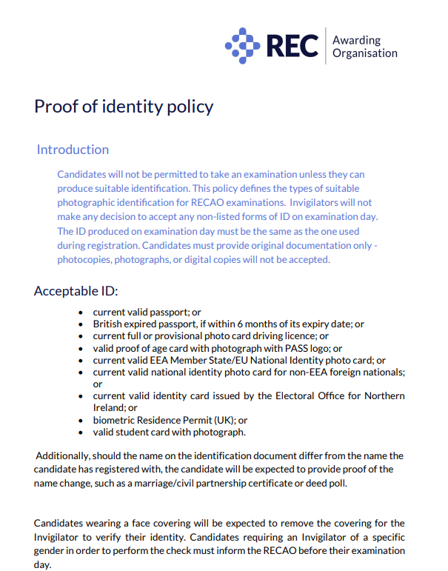

Appendix 8 Use of Artificial Intelligence
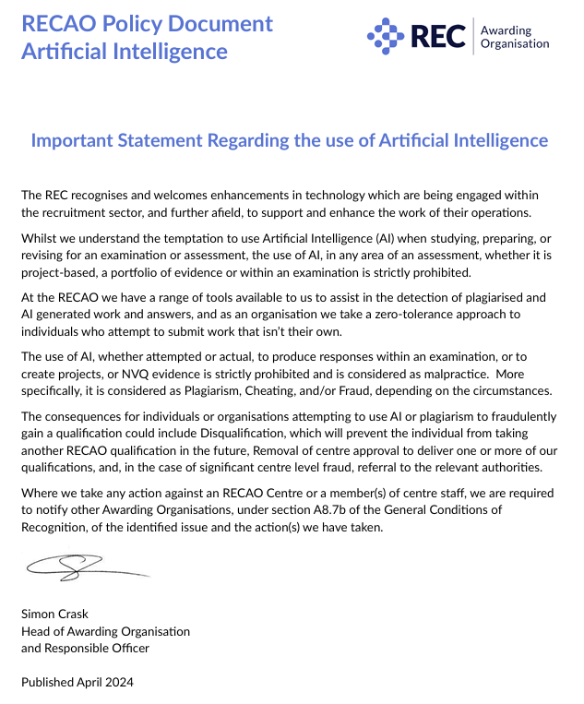

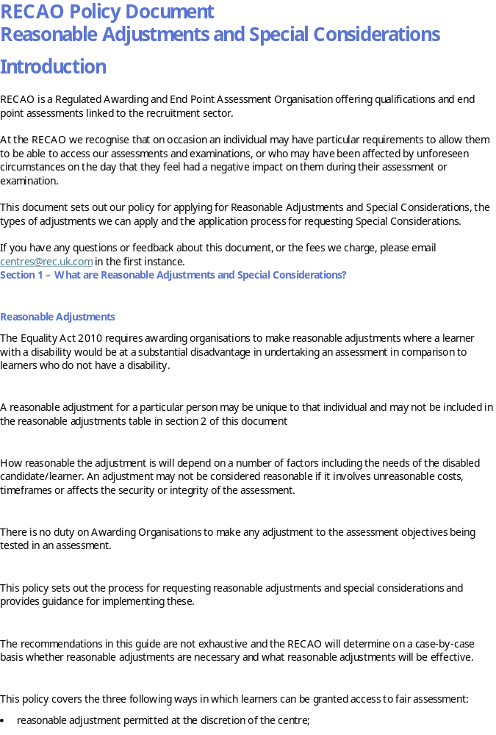
Appendix 9 Reasonable Adjustments and Special Consideration

