
Rt Hon Peter Kyle MP
Secretary of State
Department for Business and Trade
Old Admiralty Building
Admiralty Place
London
SW1A 2DY

24 April 2026

Dear Secretary of State,

The Government was elected with a mandate to restore growth. As you know, growth is delivered by a strong, competitive private sector that can invest, hire and raise wages.

Delivering growth was already challenging. Rising business costs in the UK, outpacing those in comparable economies, have squeezed margins and held back investment, pressures now intensified by global instability.

This matters to workers as well as employers. Tackling the cost-of-living crisis means addressing its twin, the cost of doing business. Competitive businesses are better able to keep prices down, create jobs and pay people more.

As four major trade bodies representing some of the UK’s largest employers in sectors most exposed to the squeezed consumer economy, the British Retail Consortium, Food and Drink Federation, Recruitment and Employment Confederation and UKHospitality represent businesses who employ millions of people across every part of the country.

We are writing in a constructive spirit to raise one area where there is still time to avoid doing further substantial damage to employment opportunities and the competitiveness of businesses based here in the UK. Addressing it pragmatically will boost flexibility and business confidence, as well as improving the prospects of workers.

The implementation of guaranteed hours rights is a huge challenge to workers and businesses alike, if the Government gets implementation wrong.

Across our sectors, concern is deep and growing that the current approach risks stripping flexibility from the labour market at precisely the wrong moment. With demand already weakened, poorly designed guaranteed hours measures could become a tipping point, pushing employers to reduce hiring, limit hours or withdraw flexible roles altogether, denying work to those who need it most, or moving to less secure, more casual models of engagement.

There is a substantial threat to good jobs

If applied rigidly, guaranteed hours requirements would increase employment costs, legal risk and administrative burden. The likely response from employers is clear, fewer roles created, fewer hours offered to avoid triggering thresholds, or a shift away from flexible jobs entirely.

Entry level roles, often the first step into work for young people, are particularly exposed. There is a real risk that the policy could end up favouring businesses willing to offer less predictable and less secure arrangements, while penalising those that already work hard to provide fair and responsible flexibility.

This risk is not theoretical. Labour market demand is stagnating rather than growing. REC data shows that, in hospitality alone, job postings fell by five per cent between February and March 2026. At a time when youth unemployment remains elevated, guaranteed hours rules could make it harder for young people to access work, cutting against the Department for Work and Pensions objectives.

In fast moving consumer goods, retail and hospitality demand fluctuates daily and seasonally. Flexible staffing is essential to productivity, cost control and business viability – especially where businesses are up against import competition. For many workers, including students, carers and others with variable availability, flexibility actively supports participation in the labour market.

If your government continues down the path of a one size fits all regulatory approach you risk reducing hours and opportunities overall, delivering lower employment rather than greater security. Many workers already have security of employment, including through well-regulated agency work, even where individual assignments vary.

There is still time to get things right

To avoid the double whammy of increasing unemployment and fewer young people entering the labour market we would like to see the government send an urgent and clear message to businesses that they should continue to hire with confidence.

You can do this by ensuring that:

- The consultation on guaranteed hours sets a reference period of at least six months as an absolute minimum. A 12-month period would most accurately reflect genuine regularity. Anything shorter would materially increase the risk of reduced hiring, fewer flexible roles and avoidable job losses. The original genesis of the guaranteed hours idea was to ensure workers who worked a regular pattern of hours over a long period had that reflected in their contract. This kind of reference period would deliver that and account for seasonal peaks, and production cycles which often extend beyond 12 weeks.

- Acknowledge that temporary agencies already operate within robust regulatory frameworks. Given the likely drive to false self-employment that inclusion of agency workers would create, we propose staged implementation and a focus on any rights granted being given by the agency, rather than the end user - thereby avoiding dampening demand. The Low Pay Commission noted that other systems – like Ireland – treated agency and temporary cover differently.

- The low hours threshold should be set at 8 hours. This is a sensible definition of low hours given this is not a power designed to be available to all workers, all the time – it was designed to protect the vulnerable.

- You urgently engage with industry to determine the framing of the consultation. Since business groups took considerable risk to reach agreement on progressing the Act in December, there has been too little discussion with businesses about the next stage. Guaranteed hours has been repeatedly raised by representatives of many sectors and cross-industry bodies, yet little has happened.

We stand ready to support you and your Department in shaping an approach that protects workers while safeguarding jobs, flexibility and growth. But this requires the genuine partnership we know you believe in on this critical issue.

Yours sincerely,

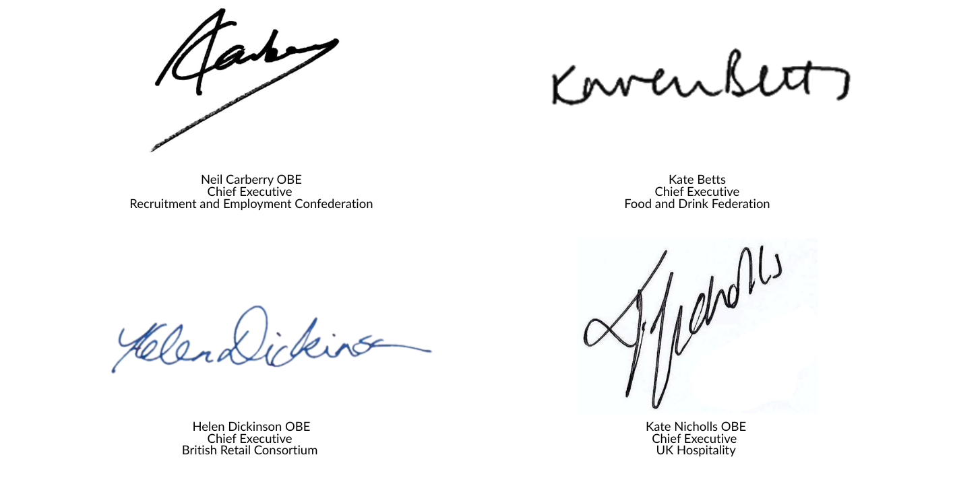

CC. Chief Secretary to the Treasury, James Murray MP

