Budget Submission
The Recruitment & Employment Confederation (REC)

October 2025



Executive Summary: A Pro-Growth Budget Is Needed to Revive the Labour Market

Our real-time labour market data tells a clear story: the UK economy is flatlining. Over the past year we have seen falling permanent placements, declining job vacancies, weak employer confidence, and muted pay growth. Candidate availability is high, yet hiring remains constrained by rising costs, persistent uncertainty, and mounting regulatory pressures, particularly in sectors such as retail and hospitality. In contrast, construction has benefitted from government-backed investment, proving that when government acts, it makes a measurable difference.

The simple, universal truth is that without a strong and sustainable labour market, the UK will not deliver the growth our economy so desperately needs. Without the capitalisation benefits of some other economies, the diversity of the UK's labour market has always played a vital role in attracting investment and driving growth. Neither business nor workers can afford for Government to get this wrong. The Chancellor must now activate policies that give employers the confidence to take their foot off the brake and invest in hiring and training. If confidence to hire isn’t turned into action, the Industrial Strategy will fall at the first hurdle.

That starts with preserving the benefits that our labour market delivers. Reckless, rushed change could slow growth for decades and lead to changes made in this Parliament being rewritten. Crucially, government must also recognise that there is no more tax to take from business. After years of rising costs, complex regulation, and economic headwinds, many firms are operating on the margins. Taxing business further would only choke off investment, reduce hiring, and weaken growth still further - delivering a tax doom loop. The next phase of the Government's economic plan must focus on enabling businesses to thrive, not penalising them. The Government is absolutely right to focus on growth because without it all fiscal policy is a self-defeating zero-sum game - but we are yet to see this focus lead the way across all of the choices Government is making. Clearing the way for businesses to drive growth and enabling them in the things, like infrastructure investment, that government funds is critical.

This Autumn Budget must be genuinely pro-business and pro-growth. This includes providing clarity and practical changes to the implementation of the Employment Rights Bill, freezing Employers' National Insurance and restoring the threshold when possible, reforming the Skills Levy to improve flexibility and drive private investment, modernising public sector hiring to save cost and improve services, supporting flexible work as a driver of better outcomes for companies and workers, and embedding a long-term workforce strategy. Deeper public-private partnerships are also essential to restore confidence, stimulate hiring and investment, and drive the sustainable growth Britain urgently needs. A successful Budget should be focussed on catalysing private sector investment - not just on public spending.

The principles that make public-private partnerships work in healthcare, construction, green energy, and other critical sectors are equally relevant to wider workforce planning. The Autumn Budget presents a practical opportunity to embed an overarching workforce strategy. A one-day summit or conference bringing together business leaders, labour market experts, and policymakers could translate strategy into action by:

- Co-creating sector-specific workforce plans to address skills gaps and regional labour needs.
- Sharing real-life employer experiences to highlight the tangible effects of policy choices.
- Aligning training, recruitment and investment priorities with industrial and infrastructure projects.
- Identifying practical steps to strengthen public-private collaboration, boost workforce participation, and improve retention.

Input from REC members will ensure the strategy reflects the realities of business and delivers measurable outcomes for workers. Government engagement in such a summit would provide a clear pathway from concept to action.

Actions Needed to Strengthen the Labour Market

- Relief for Employers: Freeze National Insurance and restore the threshold, reduce regulatory burdens, and clarify Employment Rights Bill compliance requirements.
- Skills and Training Reform: Increase levy flexibility, expand short-course funding, and boost reskilling pathways.
- Support for Workforce Participation: Accelerate childcare expansion, healthcare investment, and transport infrastructure to broaden access to work.
- Public Sector Modernisation: Reform hiring frameworks, remove rigid pay caps, and address NHS staffing bottlenecks.
- Strategic Investment Alignment: Embed workforce planning in industrial and infrastructure projects to ensure labour market needs are met.
- Public-Private Partnerships: Scale collaboration in construction, green energy, health, and other critical sectors to maximise impact.

By prioritising these actions and embedding a clear, coordinated workforce strategy, the Autumn Budget can restore business confidence, unlock investment, and deliver real opportunities for workers across the UK, creating a labour market that is stronger, more resilient, and fully capable of driving the Industrial Strategy while ensuring fairness, reform, and long-term prosperity for business and society alike.

Introduction: Job Market Analysis and Policy Priorities to Unlock Jobs and Growth

Part One presents the REC’s latest analysis of the UK jobs market, including data on employer confidence, hiring and investment trends, permanent and temporary placements, unemployment, and workforce availability. This up-to-date evidence highlights a business landscape at a crossroads: without decisive government action to reduce costs and provide certainty, hiring and investment are likely to remain subdued.

The analysis draws on multiple sources, offering a robust picture of the labour market:

- REC JobsOutlook – a monthly survey of employers conducted by Whitestone Insights on behalf of the REC, reporting on economic conditions and staffing expectations in the short and medium term.
- KPMG and REC Report on Jobs – a monthly survey of recruitment consultancies conducted by S&P Global, tracking permanent placements, temporary billings, and staff availability for the month just gone.
- REC Labour Market Tracker –detailed vacancy data from all local areas and occupations across the UK, enabling early identification of growth trends. Drawing on job postings data provided by Lightcast, it has been instrumental in charting labour market shifts during the post-COVID recovery.

Part Two sets out the REC’s policy priorities for the Autumn Budget, covering both immediate and longer-term measures. These recommendations aim to restore business confidence, stimulate job creation, and promote sustainable economic growth.

Part One: Labour Market Data Analysis Shows Untapped Potential Requires Autumn Budget Action

Data from the REC indicate that the labour market is at risk of stalling. There is clear potential in the economy that is not being realised. Consumers are sitting on cash and firms remain broadly positive about their own prospects, yet this optimism is not translating into hiring or investment. REC’s Job Outlook report shows that fear of future government action is chilling employer confidence and constraining decision-making. Permanent placements have now fallen for thirty-five consecutive months, while temporary billings continue to decline. Vacancies have dropped to their lowest level since February 2020, even as staff availability has risen sharply, reaching its highest level since November 2020. These trends underline a critical point for policymakers: the challenges in the labour market are not primarily about supply. Workers are available and willing to work, but employers are being held back by rising costs, particularly the increase in employers’ National Insurance contributions in the last Budget, along with economic uncertainty and weak confidence in the outlook, which continue to restrain recruitment and investment.

Recruitment activity across the UK continues to demonstrate persistent weakness, reflecting the broader challenges facing businesses and the wider economy. In August 2025, recruitment consultancies reported a further decline in permanent placements. While the pace of contraction was the slowest observed in the past three months, the reduction remained significant overall, highlighting ongoing uncertainty in the economic outlook and pressures from rising costs. Temporary billings also fell, albeit at a slower rate, yet the overall decline was still marked.

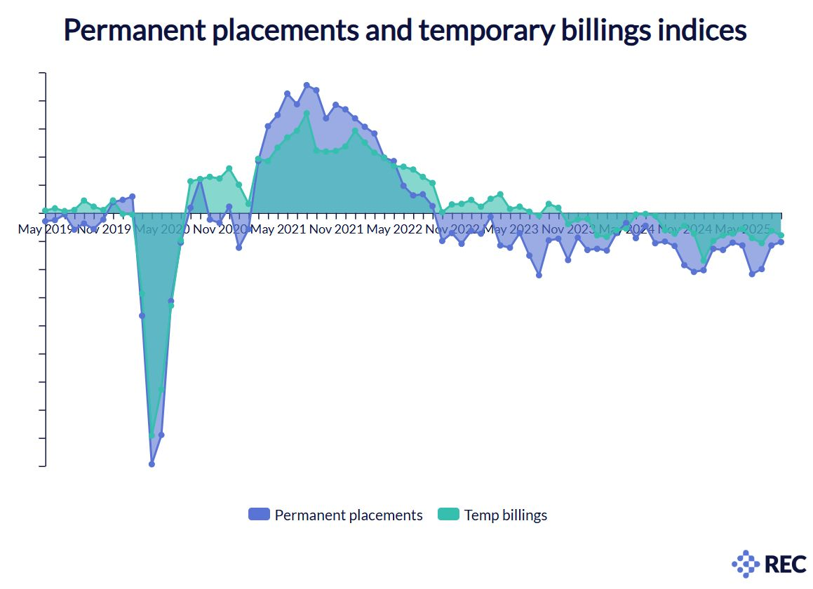
Sectoral Differences: Government Support Drives Growth In Some Sectors While Costs Suppress Confidence Overall

It is useful to consider how different sectors are performing. Construction continues to hold up relatively well, supported by government-backed infrastructure projects. Notably, activity in the sector has strengthened in line with the announcement and rollout of the Infrastructure Plan, showing the clear impact of targeted government investment.

In contrast, retail and hospitality are contracting, reflecting weak consumer demand and rising operating costs, particularly following the increase in employers’ National Insurance contributions and another inflation-busting rise in the National Living Wage. These trends reveal a consistent pattern: where government policy supports investment, confidence is maintained; where costs dominate, confidence collapses. This reinforces the case for targeted Budget measures to stimulate growth and restore employer confidence.

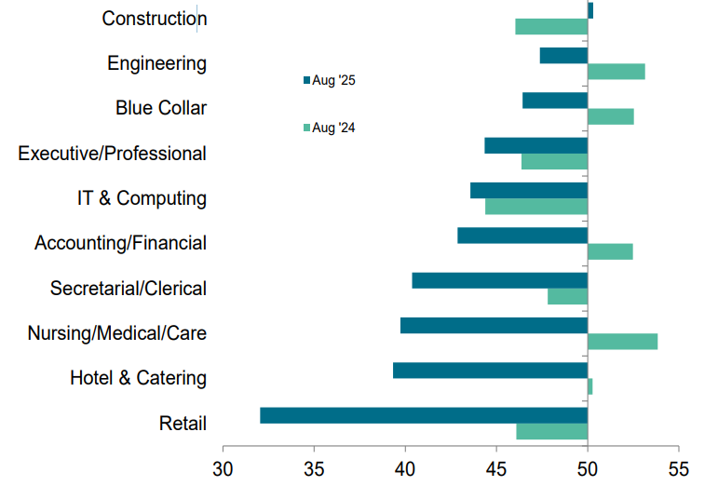

The Current State of the Labour Market: Economic Uncertainty Causes Employers to Scale Back Hiring and Investment

Over the last few years, the labour market has steadily weakened, creating widespread uncertainty for both employers and jobseekers. Headline ONS figures show some resilience in employment levels, but beneath the surface the picture is more fragile. In February to April 2025, the number of people in work stood at 34.01 million, an increase of 0.3% on the previous quarter and 2% over the year, with the employment rate edging up to 75.1%.

However, unemployment has been rising steadily since mid-2022, reaching 4.6% in the latest quarter compared with 4.1% a year ago, while economic inactivity remains high at 9.18 million people or 21.3% of the working-age population. These figures point to a labour market that is stagnating rather than recovering, with persistent challenges on both demand and supply.

The REC’s own data provides real-time insight from industry and highlights the tangible impact of economic pressures on business decisions. Our latest Topical Questions survey shows that many employers have scaled back recruitment, limited pay growth, and reduced investment in training and staff development, while others have postponed expansion plans or cut back on employee benefits to manage rising costs and protect margins. Only a small minority report making no adjustments at all, underlining how widespread these pressures have become across the economy. This weakening state of the labour market is eroding business confidence, with employers increasingly focused on cost control rather than growth and delaying investment in people and productivity. Without stronger confidence and stability, the risk is a prolonged period of stagnation that holds back economic recovery.

Regional differences: Labour Market Recovery Varies Across Regions, Highlighting Need for Targeted Policy

As is often the case, labour market performance varies significantly across the UK. While most regions are facing challenges London continues to show greater resilience, with stronger hiring activity and higher levels of job creation than elsewhere. The data shows that London is coming back earlier than other regions, and that is a signal the Government should hold onto, because London has always been the first to recover. However, the market has not remained strong throughout the year, with periods of growth followed by slower activity.

Other regions, however, are experiencing a more uneven recovery, with weaker employer confidence and slower vacancy growth. These disparities underline the importance of targeted policies that address local labour market needs, rather than relying solely on national measures.

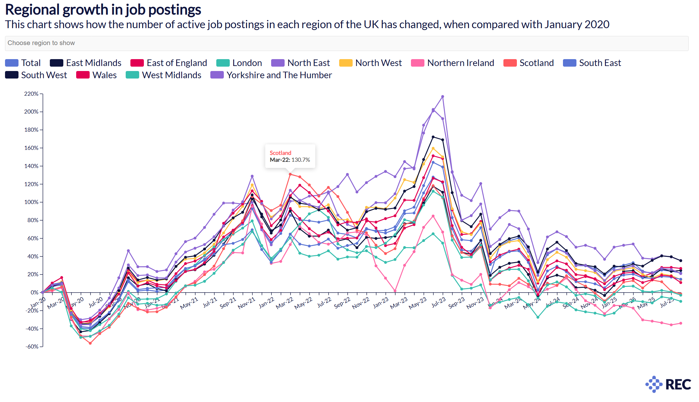

Employer Confidence: Government Action Needed to Restore Employer Confidence and Unlock Growth

Employer confidence has remained fragile throughout the year, with only brief signs of improvement. The REC’s JobsOutlook shows that while there was a temporary uptick in March (net: -3), this was swiftly followed by renewed pessimism in April. Across February to April 2025, employers’ perceptions of UK economic performance fell to net: -35, down 12 points on the previous quarter. Sentiment weakened steadily through the period, slipping from -32 in February to -38 in April. The negative movement in April is not coincidental, coinciding with increased costs for business, including rises in National Insurance contributions. Confidence in making investment and hiring decisions also declined by five points to net: -9.

This paints a clear picture of a tumultuous time for employer confidence. The Government must act quickly to seize any green shoots of optimism and turn them into sustained recovery. Permanent and temporary placements have both fallen, leading to an increase in candidate availability and a decline in vacancies, while pay and salaries have largely held steady.

Sectoral and regional variations point to where growth could return first and where targeted government action could make the biggest difference. These indicators offer a roadmap for how policy can help rebuild confidence, stimulate hiring, and unlock the potential within the UK labour market.

Permanent and Temporary Hiring: Continued to Decline Across the UK

Survey data from the latest Report on Jobs confirmed another decline in permanent hiring, extending the run of contraction to thirty-five consecutive months. The pace of decline in August was slower than earlier in the year, but still significant. Weak employer confidence around the economic outlook and concerns over costs were widely cited as reasons for holding back hiring.

The sharpest reduction in permanent placements was seen in the South of England, while the Midlands bucked the trend with a marginal increase - the first in a year. Temporary billings also contracted, though less sharply, with reductions particularly evident in the public sector.

Staff Availability and Vacancy Trends: Staff Supply Increases Amid Continuing Vacancy Decline

The seasonally adjusted Total Vacancies Index fell to 42.9 in August, the lowest level since February 2020 and the 22nd consecutive month of decline. ONS data show that vacancies dropped by 44,000 in the three months to July 2025, leaving a total of 718,000 - nearly 10 percent below pre-pandemic levels. Meanwhile, candidate availability has risen sharply. The REC’s survey data indicate the steepest rise in candidate numbers since November 2020, driven by redundancies, fewer job opportunities, and concerns over job security. In May, the Total Staff Availability Index reached 63.3, consistent with a substantial upturn, with sharp increases in both permanent and temporary staff supply across all regions of England.
It is important to note that these index figures are not percentages. A reading below 50 indicates contraction compared with the previous month, while a reading above 50 indicates growth.
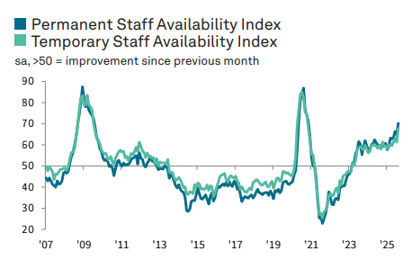

Salaries and Pay Growth: Salaries Show Muted Growth Amid Cooling Labour Market

Recruiters reported muted pay growth in August. Salaries for permanent starters increased only marginally, marking the weakest growth in four and a half years, while temporary wage inflation remained below historical trends. Geographically, starting salaries fell in both the South and North of England, with only modest increases observed in the Midlands and London.

Over the last two years, salaries given to newly placed permanent workers had risen for fifty months in a row leading up to May 2025, largely due to National Living Wage (NLW) increases and employers’ efforts to secure talent. Average hourly rates of pay for temporary staff also continued to climb through early 2025, with wage inflation at its fastest in nearly a year. However, the latest slowdown signals that demand-side weakness is now outweighing supply-side pressures.

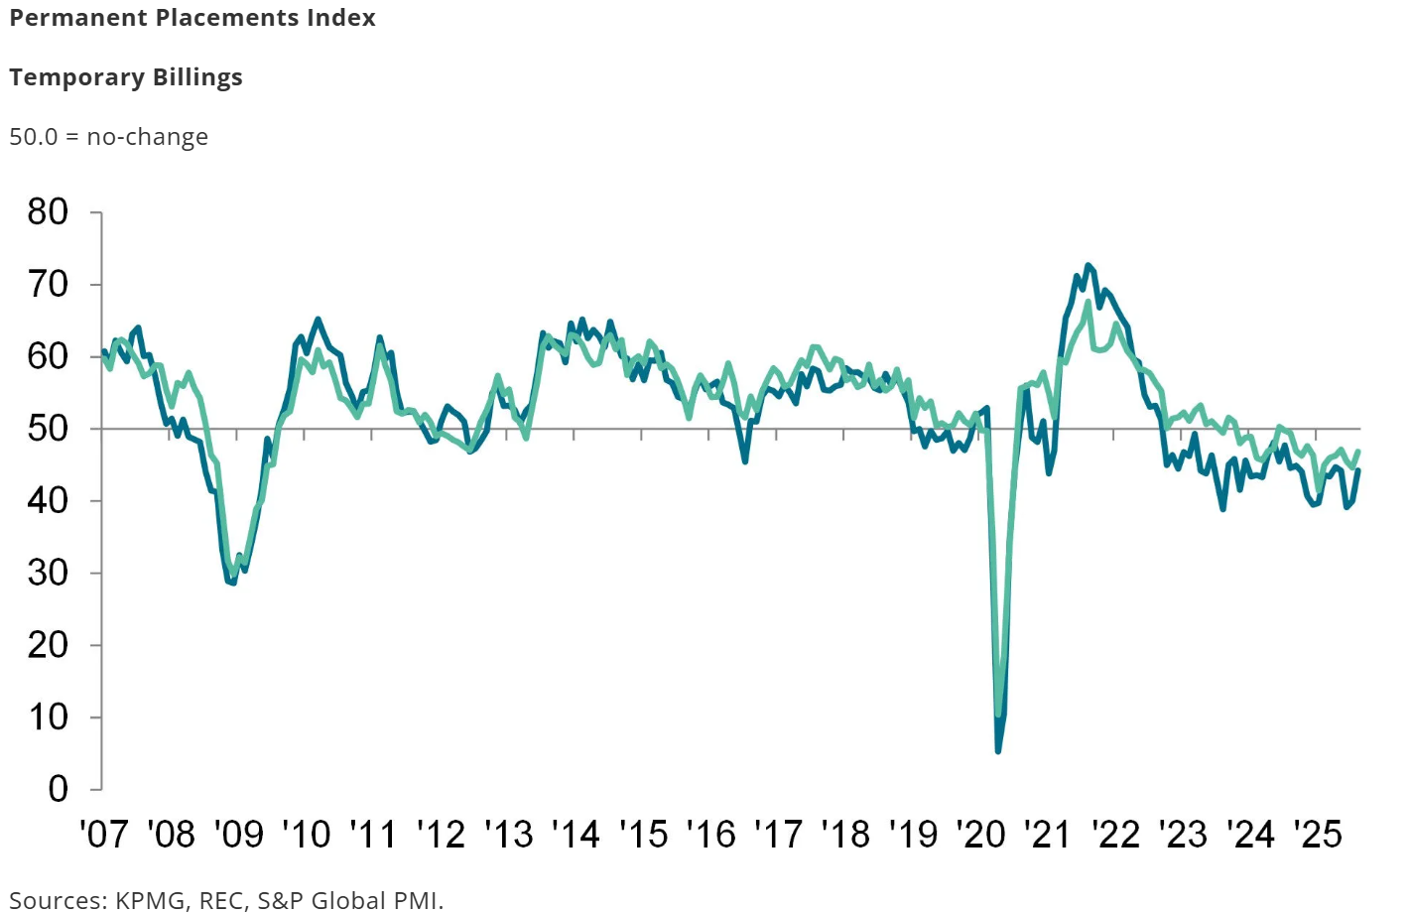

Key Takeaways: Rising Supply, Falling Demand: Policy Must Unlock Growth and Investment

The UK labour market is abundant in supply but restrained in demand. Rising staff availability alongside falling vacancies, weak pay growth, and declining confidence underscore the fragility of the jobs market. Without decisive fiscal and policy action, this environment will continue to depress hiring, wage growth, and investment.

The Autumn Budget must take a different course: easing cost pressures on employers, addressing the unintended impacts of NICs, and adopting a measured approach to NLW. Only then can policymakers restore confidence, enable firms to hire and invest, and build a resilient, high-skilled workforce to support sustainable economic growth.

Part Two: Driving Growth and Workforce Resilience - Policy Action Needed in the Autumn Budget

As the data shows, businesses face a permanently higher cost base, including the rise in Employers’ National Insurance contributions, with little prospect of relief across tax, regulation, and hiring. Many have cut margins, improved efficiency, and reduced staff, with few able to invest in technology.

July 2025 data showed zero growth, mirrored in a weak labour market where recruitment is slowing and investment remains cautious. The Autumn Budget is a vital opportunity for government to prioritise growth, job creation, and workforce participation. Without support for the labour market, GDP growth will be constrained.

Reducing Costs and Restoring Confidence: Supporting Businesses to Invest, Hire, and Grow

Too often, political debate on employment policy is framed simplistically, casting workers as the “goodies” and businesses as the “baddies.” Recent discussions around the Employment Rights Bill have followed this pattern, overlooking the reality that employers create the jobs, opportunities, and prosperity on which workers and REC members rely. Without business investment and hiring, sustainable improvements in wages, productivity, and living standards are unattainable.

REC members, and businesses more widely, are facing rising costs that directly affect their ability to recruit and retain staff. Higher energy prices, inflation in goods and services, increasing software subscriptions, and National Insurance Contributions, NICs, have all constrained hiring and investment. Changes to NICs, particularly reductions in thresholds, disproportionately affect lower-paid workers, often wiping out the equivalent of a year’s pay rise. These pressures cannot be offset simply by uprating the National Minimum Wage. Reconsideration of NICs is essential.

Policies should enable, not penalise, employers. REC members cannot plan, recruit, or invest effectively when employment costs keep rising and they are asked to absorb the full weight of economic adjustment.

Key priorities for the Autumn Budget

- Tax certainty and incentives: Avoid surprise rises in NICs, Corporation Tax, Business Rates, or new business levies. Expand full expensing, including leased and rented assets, and simplify and broaden R&D tax relief. Businesses, including REC members, do not have headroom for further increases, and reductions in Business Rates could provide a meaningful opportunity to support investment and growth.
- National Insurance: Freeze Employers' National Insurance and committing to restoring the threshold changed in last year’s Budget over time. Committing to a reverse of this costly increase is vital to protect job creation over time, preventing further hiring freezes and redundancies, and enabling firms to invest and grow.
- National Minimum Wage: The NMW has risen by over a quarter in the last three years. Businesses support a rising floor of wages - but this pace of increase, taken together with NI changes and other tax rises has left hospitality and retail businesses, who are key employers, struggling. A more moderate approach is necessary in 2026, allowing business time to adapt to the scale of increases in the past three years.
- Regulatory stability: Streamline the business environment and ensure planning reform is delivered with sufficient capacity to support REC members in making long-term investment decisions.

The Employment Rights Bill. In its current form, the ERB risks slowing opportunity and deterring hiring. Employers, including REC members, support robust protections, but laws must be clear, workable, and cost-effective. The current approach to the Bill does not deliver this, with practical business views not being included in the current draft. Government must work with businesses and unions to implement changes in a way that lasts - rather than being swept away in a future Parliament as a failure which ended up damaging both workers and their employers. Businesses do not oppose new rights - but they have expertise and understanding that has not been taken into account on how new rights will actually work.

Infrastructure and Investment: Driving Workforce Participation and economic growth

Businesses need clarity and stability to commit to long-term investment. The Autumn Budget should complement the Industrial Strategy by providing:

- A Ten-Year Infrastructure Strategy setting out a clear and bankable pipeline across energy, digital, transport, and social infrastructure to give investors the certainty needed to scale capital deployment.
- Progress reporting at fiscal events through 2026 to show how private financing for the pipeline is being secured and to signal market-making opportunities for future projects, particularly in critical national infrastructure such as grid upgrades, rail, EV charging, data connectivity, and childcare provision.

Infrastructure investment must also be designed to remove barriers to employment and increase workforce participation. Access to reliable transport and affordable childcare is essential to enabling people to secure and retain work. In many rural and underserved areas, skilled workers are excluded from the labour market not because of a lack of jobs, but because they cannot reach available roles or balance employment with caring responsibilities.

Targeted spending on local transport links will unlock labour supply, reduce skills mismatches, and increase productivity by allowing more people to access jobs. Expanding childcare provision, including extending the 30-hour entitlement to those in training, education, or returning from career breaks, would enable more parents to re-enter and progress in the workforce while also supporting greater gender equality in employment.

For REC members, these measures are vital. Firms need stable foundations from the state to deliver business investment and productivity growth. The Industrial Strategy provides a long-term framework, and the Budget should complement it by ensuring policies, funding, and incentives enable businesses to invest, expand, and create jobs.

Reform Skills and Training to Unlock Growth

The government’s skills strategy must be informed by labour market insights, ensuring investments meet real employer needs and support future workforce demand. Yet taking on workforce questions is how we tackle the systemic problems of lagging productivity, lack of skills provision, and low confidence. If we address workforce needs, we can unlock £39 bn every year of growth by giving companies access to the people and skills they need to build and grow. We will be pressing government to go further on this in both the Industrial Strategy and the Growth Plan.

Employers are clear: the Growth and Skills Levy must not be increased without reform. Too much of the current levy goes unspent because criteria are too rigid. Businesses need flexibility to use levy funds for shorter modular courses, reskilling, and upskilling temporary or flexible workers.

- Unlock the levy and commit 100% of Apprenticeship and Growth & Skills Levy receipts to training budgets, ensuring underspends return to employers via DfE and devolved nations. The lack of transparency around allocation and the gap between receipts and funding suggests levy funds are not being fully directed to skills.
- Deliver a clear roadmap for the transition from the Apprenticeship Levy to the Growth and Skills Levy. This should be published by April 2026 and set out a full transformation to a more flexible Levy by the end of this Parliament. Clear guidance will help businesses plan broader accredited training, enhance workforce development, address skills shortages, and promote informed training investments.
- Allow funding for modular courses, digital skills, and rapid reskilling for net zero and technology-driven jobs, supported by additional resources where possible. Funding raised through the Immigration Skills Charge should also be allocated to expand non-apprenticeship training under the Growth and Skills Levy, helping businesses address skills gaps and reduce reliance on overseas recruitment.
- Raise apprenticeship funding bands annually in line with inflation to ensure high-quality standards remain financially viable for providers, helping to future-proof apprenticeship funding and correct market failures where delivery costs exceed funding allocations.
- Ensure any Levy on international student income supports universities’ strategic strengths, sustainability, and competitiveness. Universities drive innovation, productivity, and growth, and funding raised through such a Levy should be reinvested in teaching, research, or maintaining access, rather than acting as a new cost burden.

Unlocking Growth through Public Private Partnerships

The Importance of Public Private Collaboration
Effective public private partnerships are essential to delivering government programmes successfully. Strong collaboration between government and business is needed to make infrastructure projects, skills programmes and employment initiatives work. To achieve meaningful outcomes, government should expand partnership models at both national and regional levels, building on the British Infrastructure Council and endorsing a new Infrastructure Finance Taskforce co-chaired by government and industry ahead of Spring 2026 to accelerate delivery and unblock barriers to investment. More initiatives that genuinely combine public and private expertise and resources are required, alongside reform of public sector staffing models. Removing rigid pay caps for health staff and modernising outdated frameworks is critical to support hiring and retention, ensuring that public services have the capacity to deliver on these joint ambitions.

Public Private Partnerships in the NHS
This is particularly important in the NHS. Planning to ban the use of agency staff by the end of the Parliament is short sighted and will push costs up rather than down as wards close due to short staffing and more care shifts move to fully private settings. Instead, government should put in place a sensible partnership model that balances permanent staff forming the backbone of the service with agency and bank staff being available to fill unavoidable gaps at fair and managed rates. If public private partnerships can be achieved in areas such as diagnostics, data and infrastructure, then staffing, which is fundamental to service delivery, should not be excluded from the same approach.

Restricting the ability of people to work flexibly through agencies will also worsen the recruitment crisis in healthcare. REC data shows nearly 42,000 job postings for nurses and medical practitioners across the UK, while many qualified medics are currently working outside the sector because the flexibility they require is not available in traditional roles. We are seeing Bank rates which are far higher than equivalent agency rates being paid by trusts, and the increasing use of lower qualifies (or unqualified) staff in some roles. These short-termist "solutions" are bad for patients, the taxpayer and the service. The Secretary of State must be willing to engage meaningfully with staffing partners to find solutions and address these issues. More can be achieved through partnership than through prohibitions. The NHS is wasting money in its anti-agency campaign.

The Department of Health and Social Care and the Treasury should convene a one-day summit to take urgent stock of the current staffing approach, set clear priorities and commit to transparent reporting of demand and all forms of temporary labour usage. This is the moment to bring structured public private partnerships to the table, drawing on the innovation and scale of the sector to transform workforce procurement and planning.

We are seeing similar ill-informed views on the role of the flexible labour market emerge in relation to supply teachers in schools and locum social workers. This must be resisted, as it will increase costs and damage performance, whether that is in emergency family and child support or in England’s schools where more classes risk being led by unqualified staff.

Youth Employment Guarantee
Another area of public and private collaboration significant to this budget is the recently announced Youth Employment Guarantee. The principles that make public private partnerships work in healthcare, such as collaboration, flexibility and employer engagement, are equally critical to tackling long term youth unemployment. The Youth Employment Guarantee scheme offers a major opportunity to give young people a meaningful start in their careers, but it will only succeed if it embraces the same partnership ethos. Reducing long term youth unemployment is vital to the Government’s growth mission, and employers across our sector are ready to play their part in creating opportunities. Our data highlights the scale of the challenge. In August 2025, new job postings in the UK fell to 661,639, a 3.8 percent decrease from July, while total active postings stood at 1,447,620, down 1.6 percent.

The success of the Youth Employment Guarantee will depend on effective delivery and strong public private collaboration. Lessons from previous initiatives such as Kickstart demonstrated that bureaucracy often blocked willing businesses from offering placements. To ensure the scheme works, several factors are essential. The system must be straightforward to access and quick to process. Employers must be at the heart of scheme design, with minimal administrative barriers. The Department for Work and Pensions must be properly resourced so work coaches can focus on supporting participants. Lessons from initiatives such as Restart should be applied to ensure effective public private collaboration and tangible outcomes. Expansion of public private partnership models at national and regional levels should be prioritised, building on the British Infrastructure Council and the new Infrastructure Finance Taskforce to accelerate delivery and unblock barriers to investment.

Driving Innovation Through Contracts for Innovation

In addition, contracts for innovation should be expanded across departments, scaling successful Commercial Innovation Hub trials to embed innovation pull through in procurement and enabling government to act as an anchor customer for new technologies. This matters for members because it gives businesses greater certainty and access to early government demand, helping them scale innovative products and services while driving productivity and growth. By taking this approach, government can ensure that innovation and workforce development go hand in hand, delivering tangible benefits for businesses, public services and the economy.

Fair and Targeted Enforcement in the Umbrella Company Market

Umbrella company reform must be approached with fairness and clarity over enforcement responsibilities. HMRC has the tools and authority to regulate tax compliance, yet current proposals risk shifting policing duties onto recruitment businesses and end hirers rather than targeting wrongdoing at source. While it is positive that government now acknowledges tax avoidance within parts of the umbrella market, much of the public narrative fails to distinguish between rogue providers and the compliant majority operating legitimately within the temporary labour market.

Recruiters already conduct due diligence, but unlike HMRC they do not have access to tax information or the legal powers needed to uncover non-compliance, and they cannot reasonably be expected to verify payroll models where transparency is limited. Placing liability on intermediaries who lack both control and visibility risks punishing businesses for the actions of third parties over whom they have no contractual authority. Employment businesses are already navigating a contracting labour market and significant legal change; loading them with additional tax enforcement responsibilities would further erode confidence and capacity. A credible compliance regime must focus enforcement on those handling pay and deductions and ensure that good actors are not penalised for the behaviour of a few bad ones.

Longer-Term Priorities: Building a Skilled, Inclusive, and Future-Ready Workforce

A coherent, long-term workforce strategy is essential for linking industrial policy with labour market planning and ensuring that the UK’s growth is inclusive, sustainable, and skills driven. To achieve this, workforce planning must be embedded in industrial and infrastructure projects so that labour market needs are met.

Government should work closely with business to widen participation, address structural barriers such as economic inactivity, and ensure that growth sectors have the right skills pipelines in place. By aligning investment, training, and employment initiatives, this approach can create sustainable economic growth while providing meaningful opportunities for workers across all regions and sectors.
Key elements include:

- Promote temporary and flexible work as a route into the labour market for underrepresented groups, including young people, carers, and those returning after long-term absence. Flexible work should be recognised as a legitimate pathway into long-term employment.
- Embed workforce planning into industrial and infrastructure projects, ensuring that major investments such as construction, green energy, digital infrastructure, and manufacturing are supported by targeted skills development and clear recruitment pipelines.
- Align investment incentives with skills development, ensuring that public and private investment in infrastructure, technology, and high-growth sectors is matched with workforce training programmes, apprenticeships, and reskilling initiatives.
- Strengthen public-private collaboration, drawing on expertise from business, local authorities, and education providers to co-design workforce solutions that address regional disparities and sector-specific skills gaps.
- Address structural barriers to participation, including economic inactivity, childcare availability, transport access, and digital inclusion, so that all communities can benefit from economic growth.
- Monitor and evaluate outcomes, using data from employers and skills providers to continuously refine workforce planning and ensure interventions deliver measurable results.

By integrating these elements, the UK can build a workforce strategy that is forward-looking, responsive to industrial needs, and inclusive, ensuring that economic growth benefits workers across all regions and sectors.

About the REC

The Recruitment & Employment Confederation (REC) is the professional body for the UK recruitment industry. We represent over 3,000 recruitment businesses and 11,500 individual recruiters. The UK recruitment sector places over a million people into permanent jobs each year and ensures that a further one million are working flexibly through temporary assignments on any given day. The professional staffing sector is bigger in scale than either law or accountancy and contributed over £44 billion to UK GDP in 2023.

As a representative of thousands of UK employers, who place thousands of workers into jobs, both temporary and permanent, the REC is uniquely positioned to provide insight into what actions can be taken to improve and enhance the economy, create and protect jobs.

For further information or if you have any questions please contact: Holly Whitbread, Public Affairs Advisor on holly.whitbread@rec.uk.com

